Mason’s Lab 1 Reflection
001241528
Mason Tehrani
Oct 4 2026
Lab 1

The lab is currently fully functional, the user can create, edit delete and view companies as well as login in with pre-loaded accounts and create unauthorized accounts

Three things I learned
- Leaving things to the last minute is a bad idea (you would think I would have learned this by now)
- Having the scaffolding create a folder called company, but the controller looking for companies causes quite the headache and took far to long to track down and correct
- There is required in both the c# and the html for registration, had to account for that so that city could be allowed to be added or not left blank

Areas for improvement
- Time management
- Naming conventions
- Overall attention to detail to save myself time instead of going on fool’s errand bug hunts
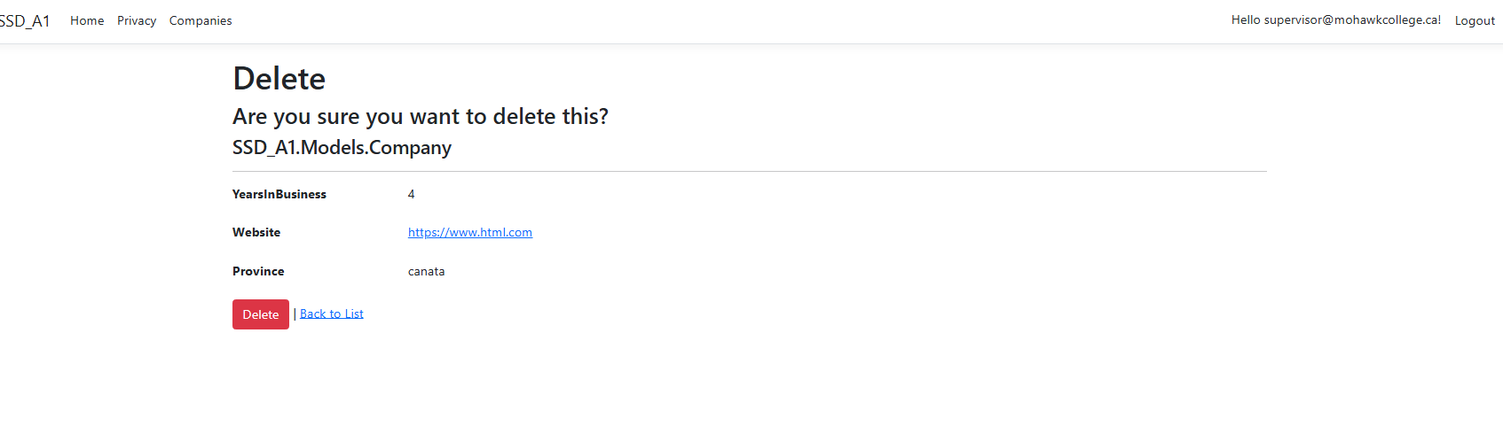
Supervisor able to delete company
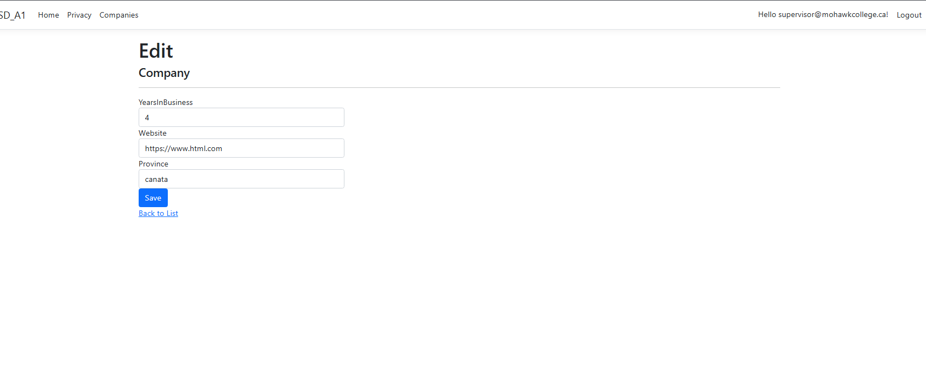
Supervisor able to edit company
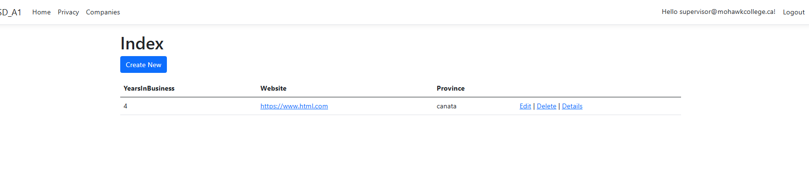
Supervisor able to see edit, delete and create company
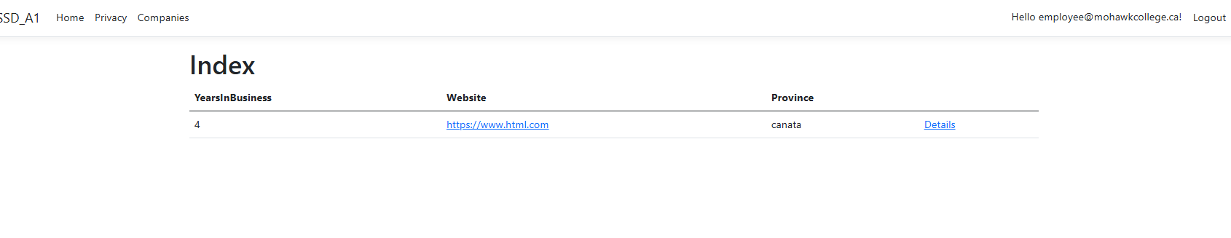
Employee unable to see edit, delete or create
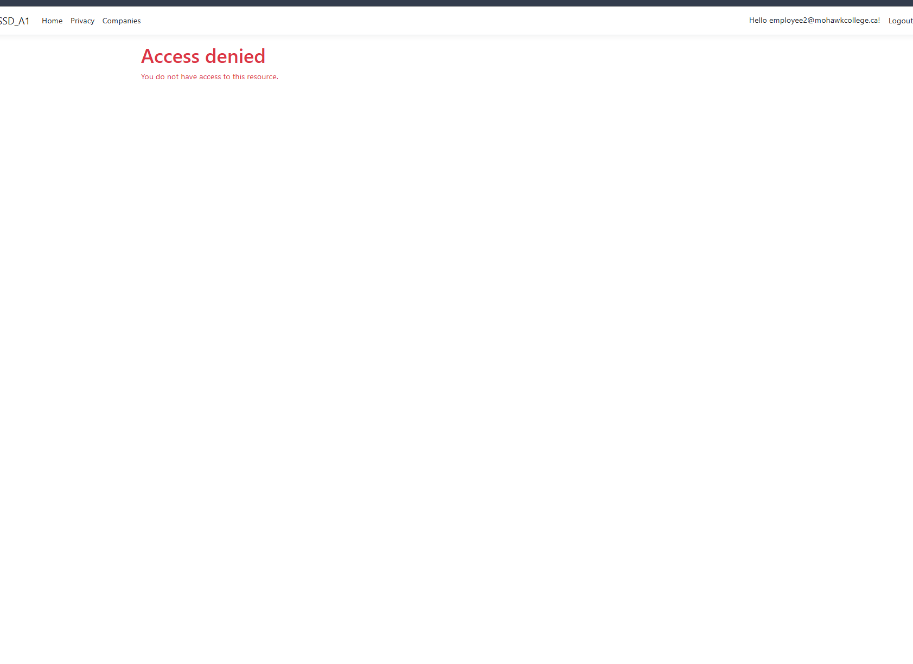
Unauthorized user unable to access company view
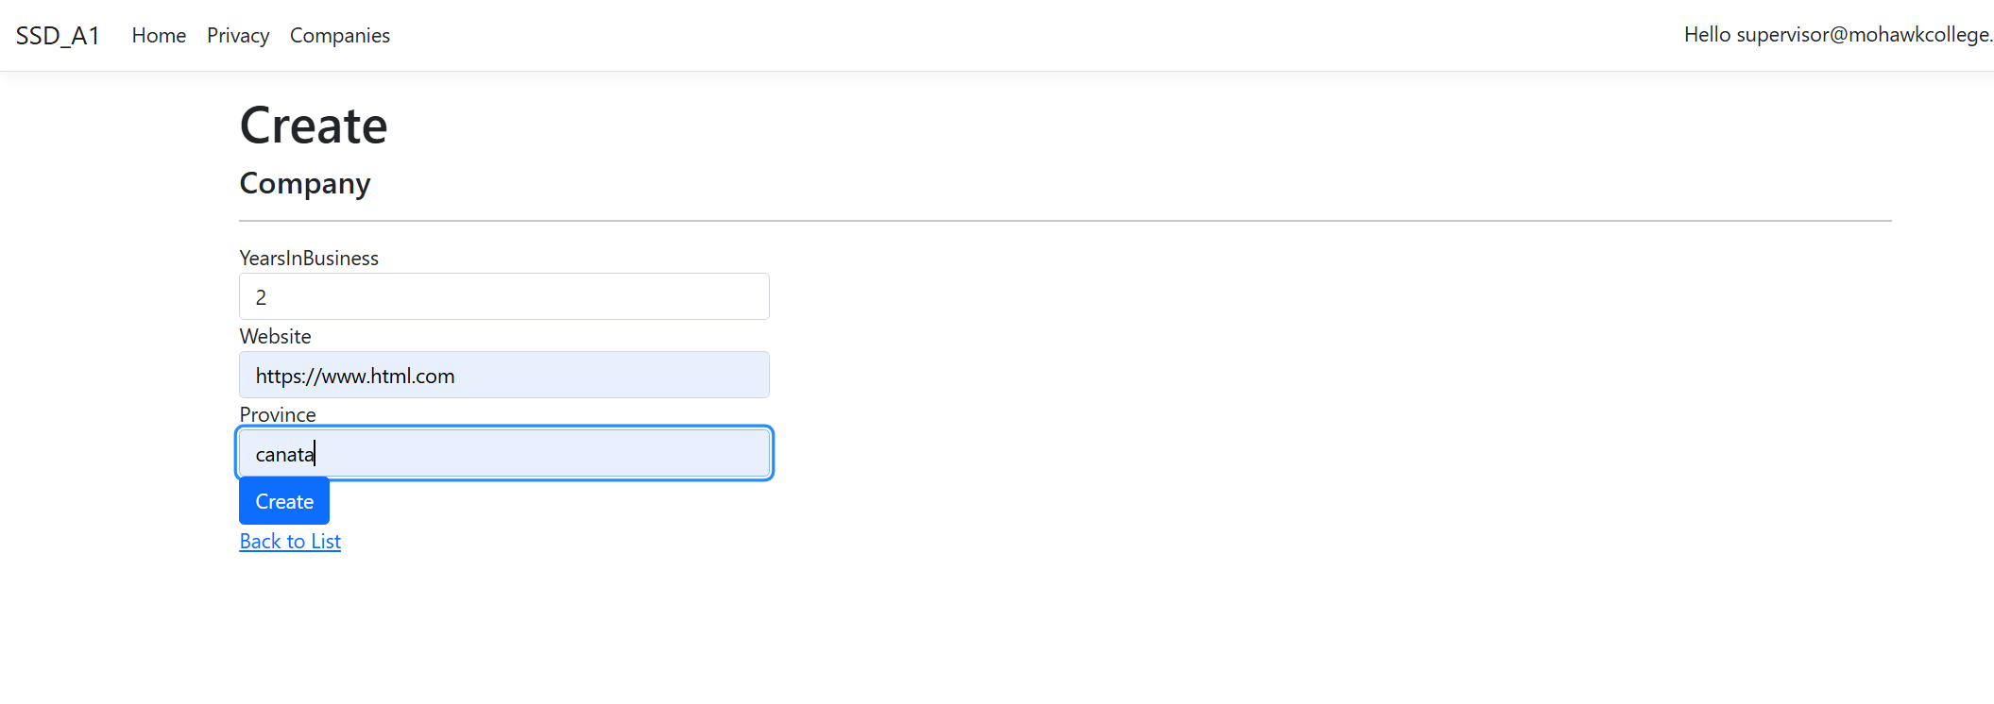
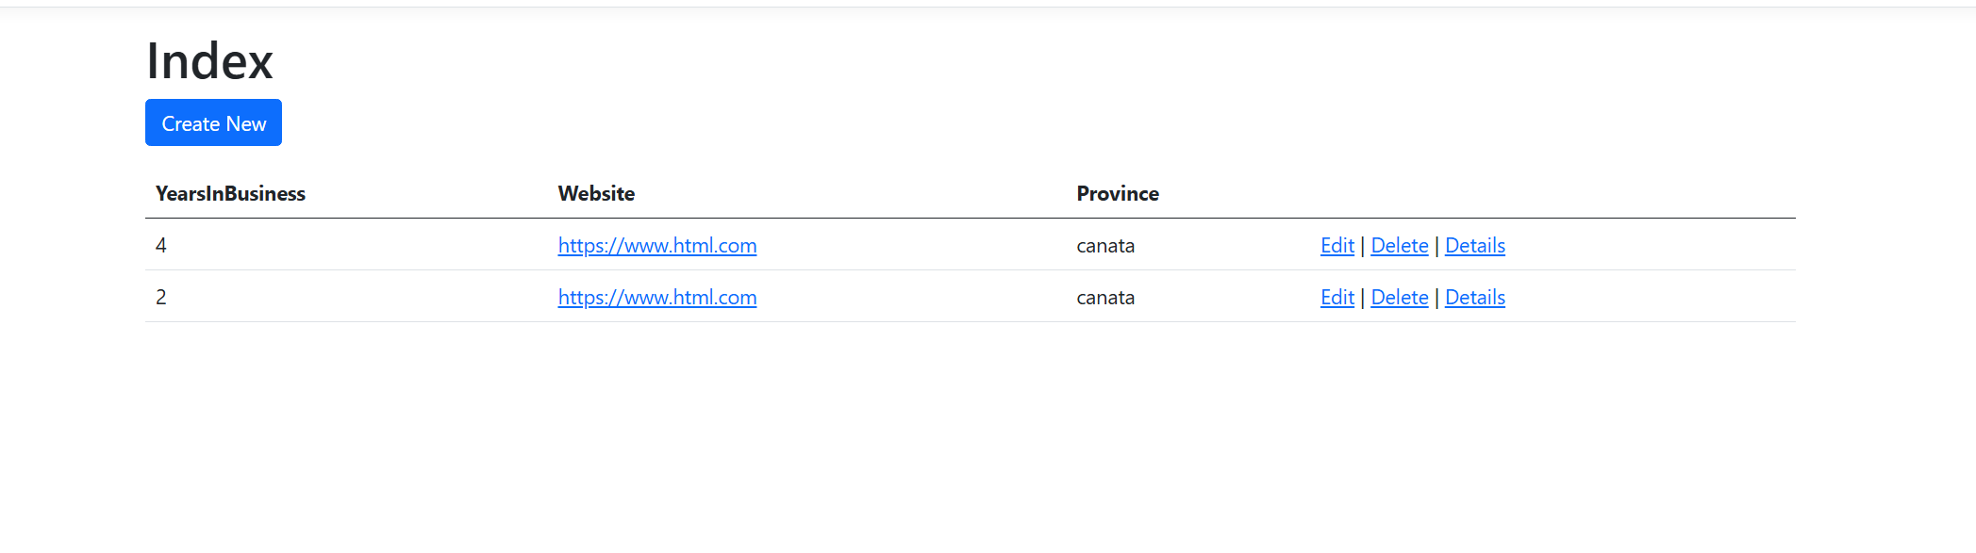 supervisor creating new company
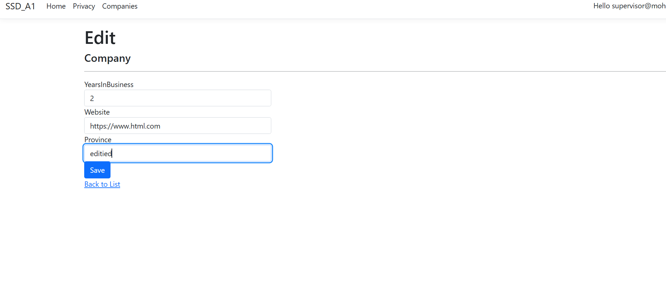
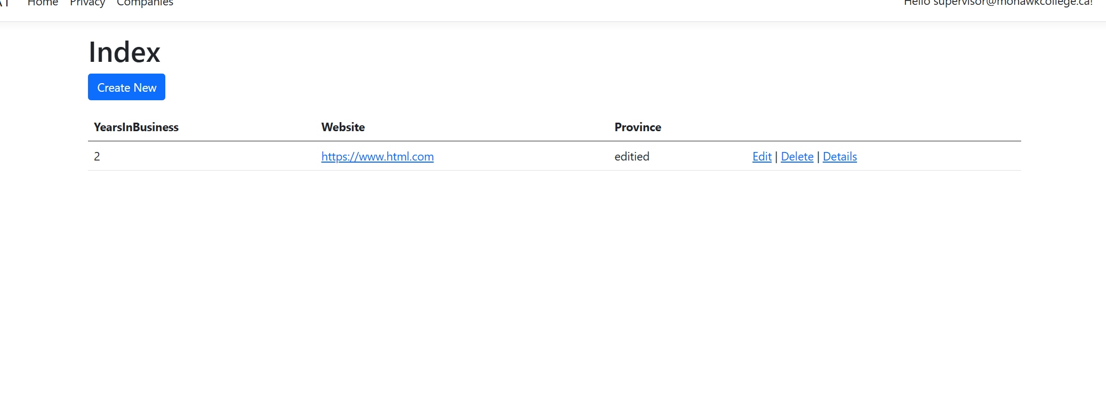supervisor editing existing company (done after deleting the one that was in business for 4 years)

